# CS 255 System Design Document Template

This template lays out all the different sections that you need to complete for Project Two. Each section has guidance to prompt your thinking. You will need to continually reference the interview transcript as you work to make sure that you are addressing your client’s needs. There is no required length for the final document. Instead the goal is to complete each section based on what your client’s needs are. Remove this note when you are finished, and replace all bracketed text with the relevant information.

## UML Diagrams

### UML Use Case Diagram

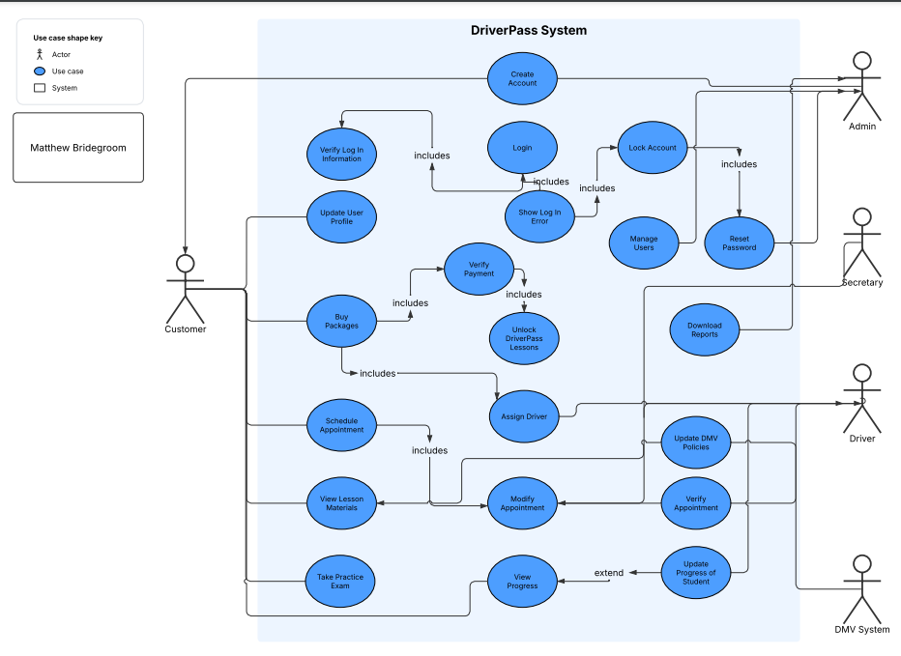

### UML Activity Diagrams

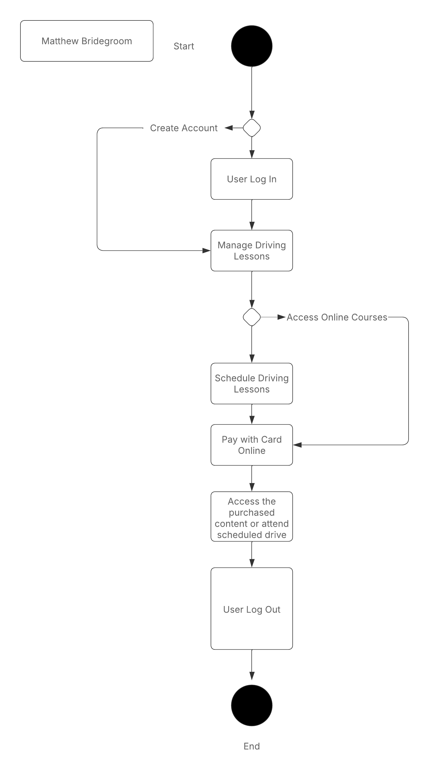

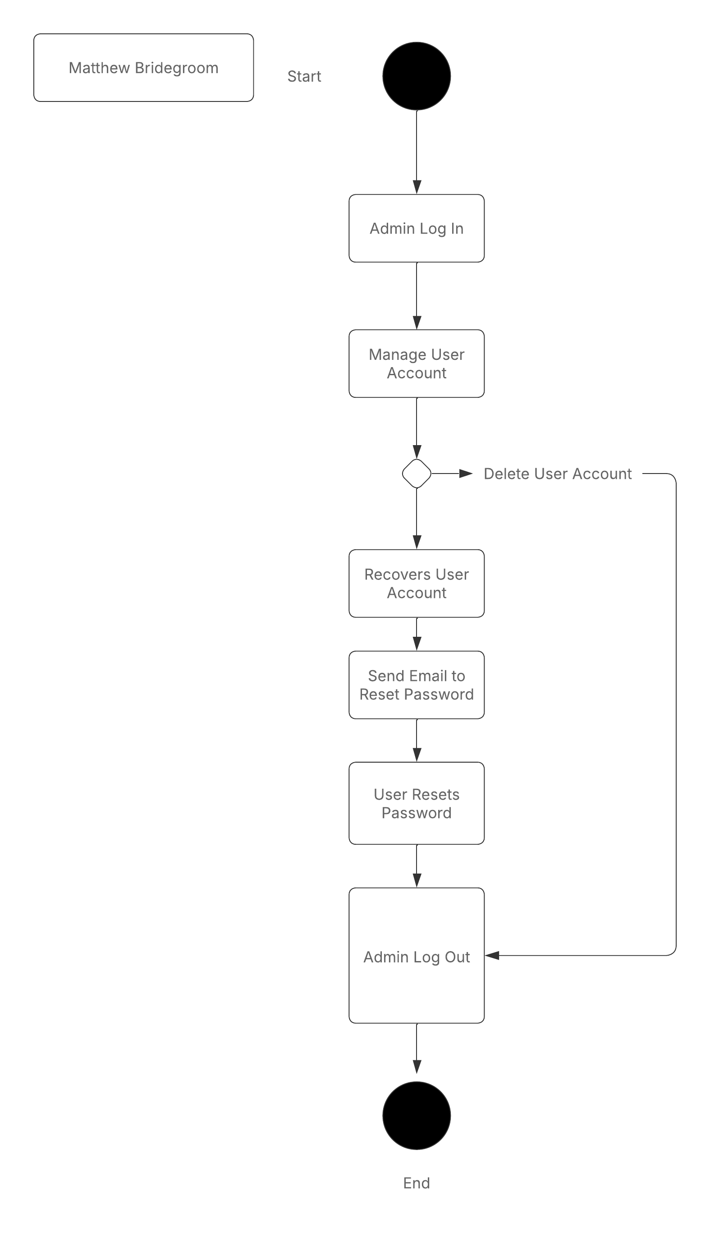

### UML Sequence Diagram

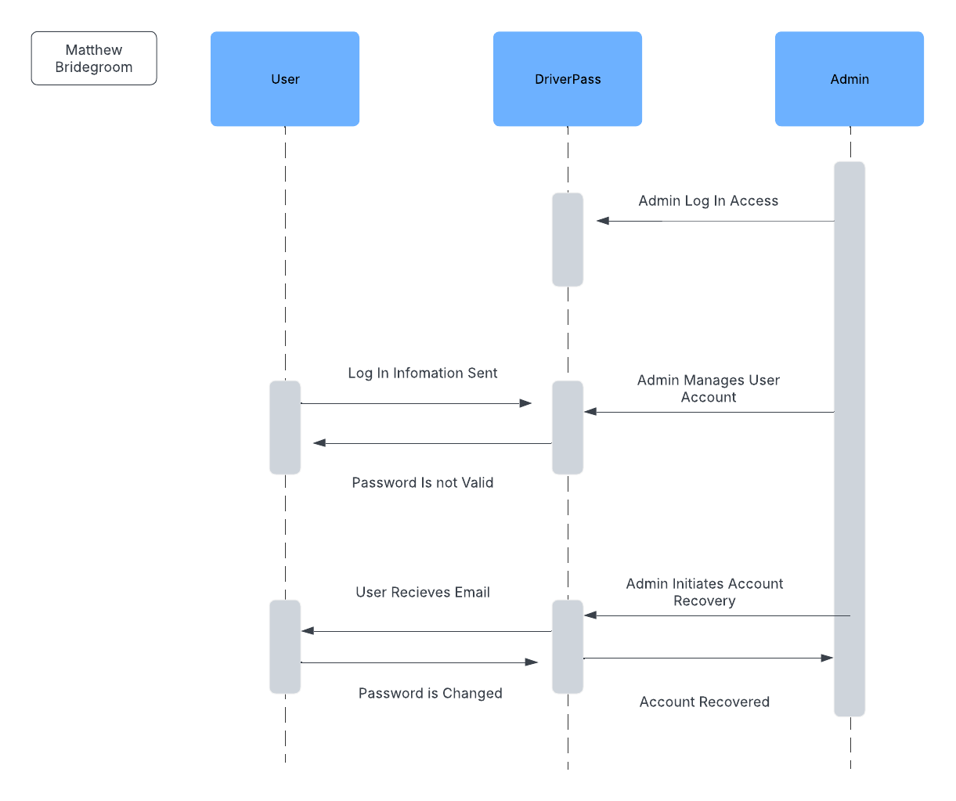

### UML Class Diagram

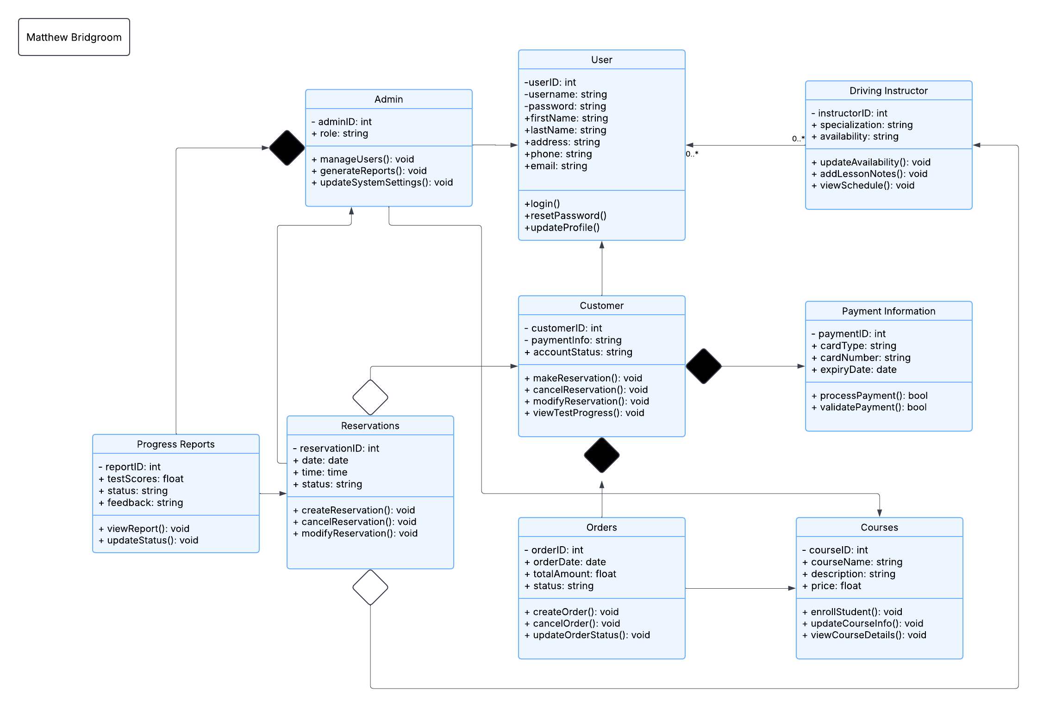

## Technical Requirements

*[Based on the diagrams you have created, describe the technical requirements of your system. These requirements should address the required hardware, software, tools, and infrastructure necessary for your system design.]*

**Hardware**

* In order to support the load of the user, physical servers will be needed to host DriverPass.
* The different users will also need to have access to a device, such as a phone or computer.
* Having routers set up will help to ensure connectivity online for any access to the system.

**Software**

* The system will need to have an OS to run on such as Linux for the servers.
* The system also needs to have a built-in database such as MySQL to support the bulk of ever-changing information.
* A web server will also be needed to handle the HTTP requests on the servers.
* A secure software will need to be built into DriverPass such as SSL to ensure safe data transfers.

**Tools**

* Access to Github or a related repository for the use in managing system updates and keeping changelogs.
* A development platform such as Visual Studios or PyCharm to support the development of DriverPass
* DriverPass will also need to bring tools to support the testing of both the API and the frontend of the system

**Infrastructure**

* Cloud Services such as Azure or AWS to handle hosting and storage of data.
* DriverPass will also need to support different APIs for actions like payment processing
* Lastly a monitoring system would help to provide another level of security for the system, this could also be utilized to monitor the performance of the system and alert during downtime.